**AlbumController – Build Add Album API**

**Create a DTO album in payload folder -> AlbumPayloadDTO.java**

package org.studyeasy.SpringRestdemo.payload.auth.album;

import io.swagger.v3.oas.annotations.media.Schema;

import io.swagger.v3.oas.annotations.media.Schema.RequiredMode;

import jakarta.validation.constraints.NotBlank;

import lombok.AllArgsConstructor;

import lombok.Getter;

import lombok.NoArgsConstructor;

import lombok.Setter;

import lombok.ToString;

@Getter

@Setter

@ToString

@NoArgsConstructor

@AllArgsConstructor

public class AlbumPayloadDTO {

    @NotBlank

    @Schema(description = "Album name", example = "Travel", requiredMode = RequiredMode.REQUIRED)

    private String name;

    @NotBlank

    @Schema(description = "Description for the Album", example = "description", requiredMode = RequiredMode.REQUIRED)

    private String description;

}

**Create a DTO album in payload folder -> AlbumViewDTO.java**

package org.studyeasy.SpringRestdemo.payload.auth.album;

import io.swagger.v3.oas.annotations.media.Schema;

import io.swagger.v3.oas.annotations.media.Schema.RequiredMode;

import jakarta.validation.constraints.NotBlank;

import lombok.AllArgsConstructor;

import lombok.Getter;

import lombok.NoArgsConstructor;

import lombok.Setter;

import lombok.ToString;

@Getter

@Setter

@ToString

@NoArgsConstructor

@AllArgsConstructor

public class AlbumViewDTO {

    private long id;

    @NotBlank

    @Schema(description = "Album name", example = "Travel", requiredMode = RequiredMode.REQUIRED)

    private String name;

    @NotBlank

    @Schema(description = "Description for the Album", example = "description", requiredMode = RequiredMode.REQUIRED)

    private String description;

}

**Create a enum in util folder -> AlbumSuccess.java and AlbumError.java**

**AlbumSuccess.java**

package org.studyeasy.SpringRestdemo.util.constants;

public enum AlbumSuccess {

    ALUBM_ADDED

}

**AlbumError.java**

package org.studyeasy.SpringRestdemo.util.constants;

public enum AlbumError {

    ADD_ALBUM_ERROR

}

**Updated AlbumController.java**

package org.studyeasy.SpringRestdemo.controller;

import java.util.Optional;

import org.springframework.beans.factory.annotation.Autowired;

import org.springframework.http.HttpStatus;

import org.springframework.http.ResponseEntity;

import org.springframework.security.core.Authentication;

import org.springframework.web.bind.annotation.PostMapping;

import org.springframework.web.bind.annotation.RequestMapping;

import org.springframework.web.bind.annotation.ResponseStatus;

import org.springframework.web.bind.annotation.RestController;

import org.studyeasy.SpringRestdemo.model.Account;

import org.studyeasy.SpringRestdemo.model.Album;

import org.studyeasy.SpringRestdemo.payload.auth.album.AlbumPayloadDTO;

import org.studyeasy.SpringRestdemo.payload.auth.album.AlbumViewDTO;

import org.studyeasy.SpringRestdemo.service.AccountService;

import org.studyeasy.SpringRestdemo.service.AlbumService;

import org.studyeasy.SpringRestdemo.util.constants.AlbumError;

import io.swagger.v3.oas.annotations.Operation;

import io.swagger.v3.oas.annotations.parameters.RequestBody;

import io.swagger.v3.oas.annotations.responses.ApiResponse;

import io.swagger.v3.oas.annotations.security.SecurityRequirement;

import io.swagger.v3.oas.annotations.tags.Tag;

import jakarta.validation.Valid;

import lombok.extern.slf4j.Slf4j;

@RestController

@RequestMapping("api/v1/album")

@Tag(name = "Album Controller", description = "Controller for Album and Photo management")

@Slf4j

public class AlbumController {

    @Autowired

    private AccountService accountService;

    @Autowired

    private AlbumService albumService;

    @PostMapping(value = "/albums/add", consumes = "application/json", produces = "application/json")

    @ResponseStatus(HttpStatus.CREATED)

    @ApiResponse(responseCode = "400", description = "Please add valid name for description")

    @ApiResponse(responseCode = "201", description = "Account added")

    @Operation(summary = "Add an album")

    @SecurityRequirement(name = "studyeasy-demo-api")

    public ResponseEntity<AlbumViewDTO> addAlbum(@Valid @RequestBody AlbumPayloadDTO albumPayloadDTO,

            Authentication authentication) {

        try {

            Album album = new Album();

            album.setName(albumPayloadDTO.getName());

            album.setDescription(albumPayloadDTO.getDescription());

            // Extract Account

            String email = authentication.getName();

            Optional<Account> optionalAccount = accountService.findByEmail(email);

            Account account = optionalAccount.get();

            album.setAccount(account);

            album = albumService.save(album);

            AlbumViewDTO albumViewDTO = new AlbumViewDTO(album.getId(), album.getName(), album.getDescription());

            return ResponseEntity.ok(albumViewDTO);

        } catch (Exception e) {

            log.debug(AlbumError.ADD_ALBUM_ERROR.toString() + ": " + e.getMessage());

            return ResponseEntity.status(HttpStatus.BAD_REQUEST).body(null);

        }

    }

}

**In SecurityConfig.java -> update below line**

.requestMatchers("/").permitAll()

**to**

.requestMatchers("/**").permitAll()

**Updated application.properties**

# Server port

Server.port=8080

# Database config

spring.datasource.url=jdbc:h2:file:./db/db

spring.datasource.driverClassName=org.h2.Driver

spring.datasource.username=admin

spring.datasource.password=pass987

spring.jpa.database-platform=org.hibernate.dialect.H2Dialect

# setup local h2 database console

spring.h2.console.enabled=true

spring.h2.console.path=/db-console

spring.h2.console.settings.web-allow-others=false

security.headers.frame=false

# local h2 tables setup on startup; use the value "none" in production!

spring.jpa.hibernate.ddl-auto=create-drop

# Logging setting

logging.level.org.studyeasy=DEBUG

logging.pattern.console=%d [%level] %c{1.} [%t] %m%n

logging.file.name = appLog.log

logging.pattern.file=%d [%level] %c{1.} [%t] %m%n

**There was an error facing in controller - Wrong Import**

import org.springframework.web.bind.annotation.RequestBody;

• **Incorrect Import**: In the latest version, the @RequestBody annotation is incorrectly imported from io.swagger.v3.oas.annotations.parameters.RequestBody. This is a Swagger annotation used for documentation purposes, not for binding HTTP request bodies to method parameters.

• **Correct Import**: The @RequestBody annotation should be imported from org.springframework.web.bind.annotation.RequestBody, as this is the one that binds the HTTP request body to the method parameter in Spring.

**Output**

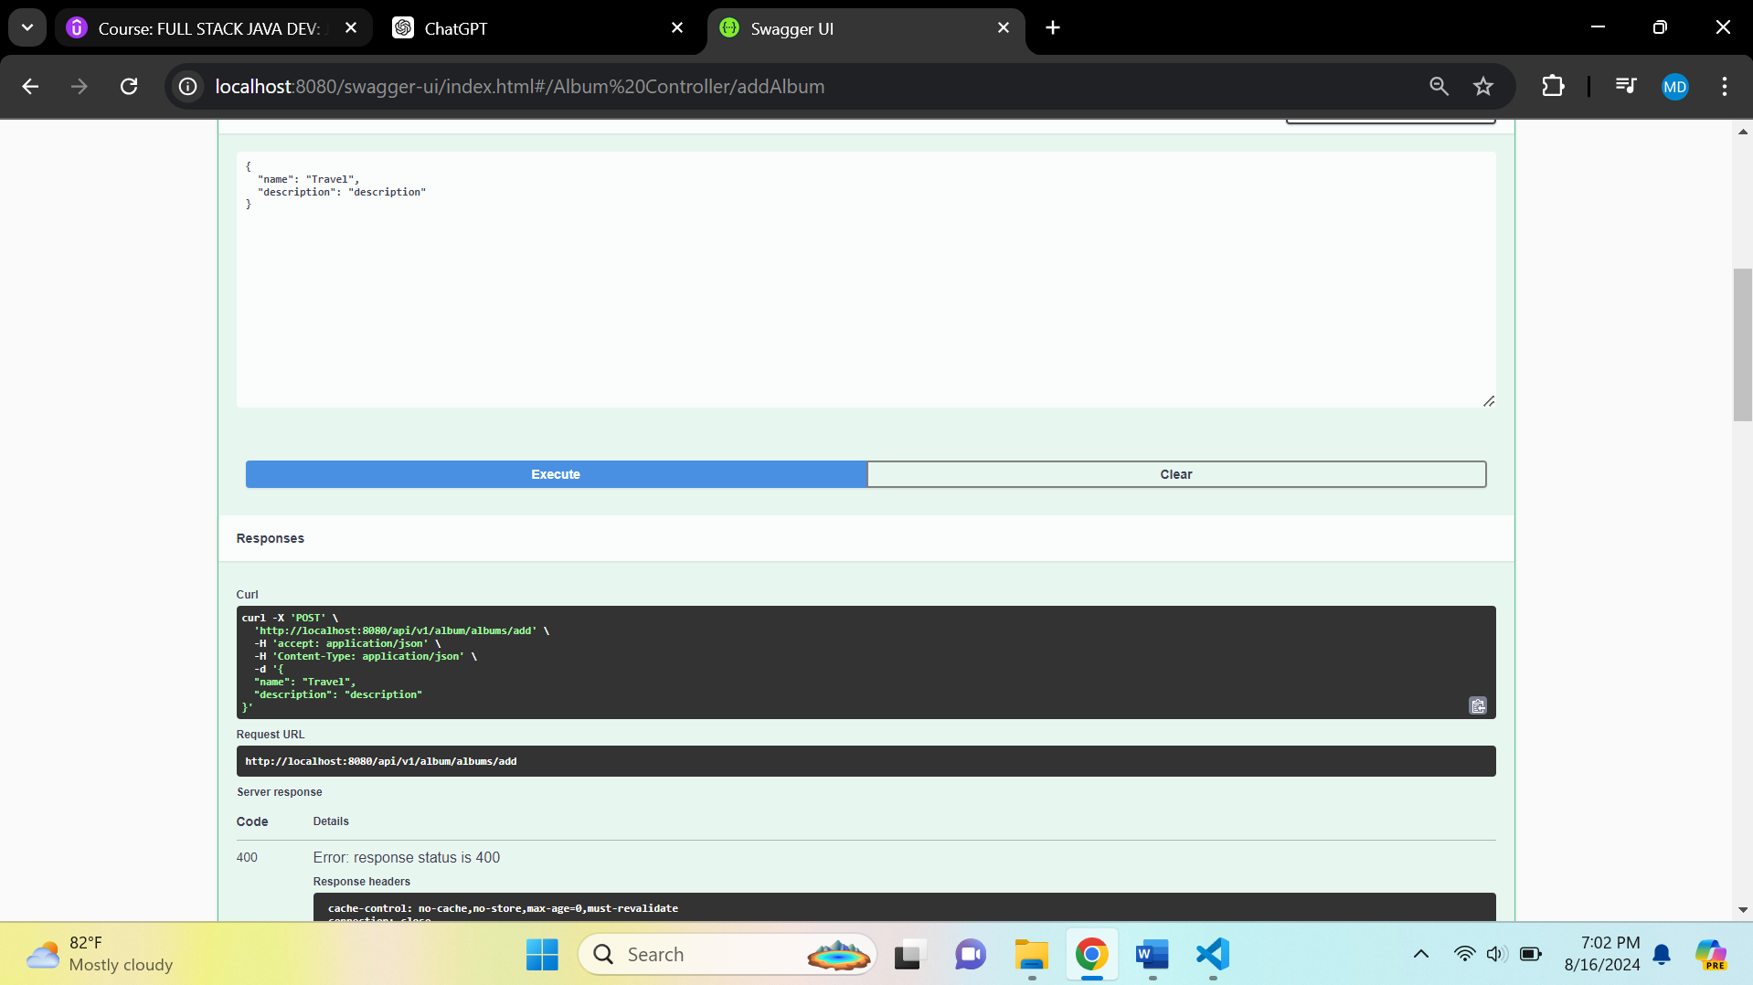

**Try to login by generating a token and authorize and then try to add album**

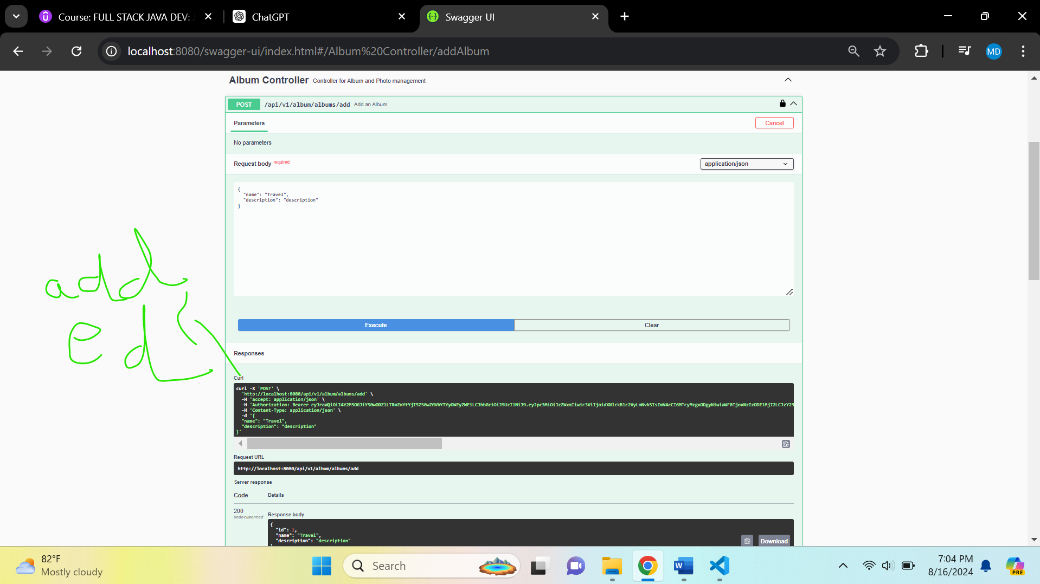

**Db console**

